# TECHNECO ELGA HYBRID HEAT PUMP DESIGN MANUAL

**INTRODUCTION**

Techneco developed a solution that is as simple as it is effective: the ELGA hybrid heat pump, a smart modulating heat pump that works together with an (existing) gas boiler or district heating. In addition to heating in winter, the ELGA can cool the wound in the summer. With its attractive payback period, the ELGA ensures an advance of the energy-efficient home!

The ELGA (Electric heat pump for the GA boiler) is an air-water heat pump with an indoor and outdoor unit. The small indoor unit is placed next to a gas boiler or at the connection of the urban impoverishment. The high efficiency outdoor unit is placed at a minimum of 2 and a maximum of 20 meters from the indoor unit. A ground coupled source is not necessary! The ELGA can be installed in one day, is suitable for almost any home and can be placed in both the new building and in an existing home. The ELGA can be combined with gas boilers from Intergas, Remeha, Vaillant, AWB, ATAG, Ferroli, Itho / Daalderop, Nefit and Bosch, but can also be placed in homes connected to district heating!

# action

The ELGA uses energy from the outside air and converts it into usable heat for the home. The outdoor unit extracts the heat from the air. The heat pump adds this energy to the water of the central heating system. The water can be heated to a maximum of 50°C. The ELGA generates up to 4.9 kW of heating power. In a Dutch climate, this means a saving of 50% to 90% on gas or heat use depending on the size, insulation, and delivery system of the home. With the help of the online calculation tool, it can be determined specifically per home what the annual savings can be on the energy bill. The tool can be found at: [www.besparen-warmtepompen.nl](http://www.besparen-warmtepompen.nl/)

# cooling function

The need to be able to cool in the summer is increasing. By installing fan convectors with a condensation drain or the use of underfloor heating, the cooling function of the ELGA can be used. With a minimum of energy, the ELGA lowers the temperature in the house by a number of degrees.

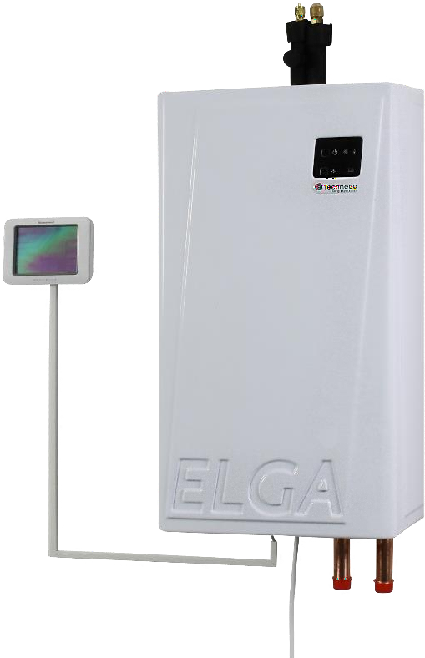 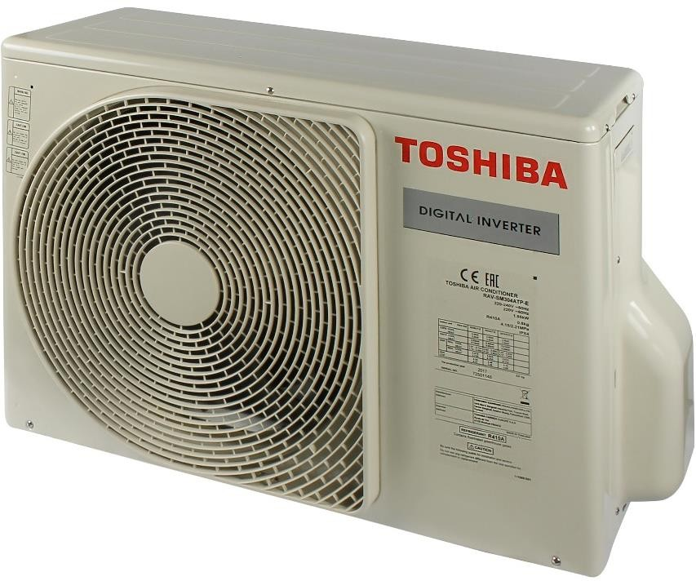

For more information about the ELGA, visit [www.techneco.nl](http://www.techneco.nl/)

|  |  |  |
| --- | --- | --- |
| **SPECIFICATIONS TEXT** | | |
| » | manufactured | Techneco in Delft |
| » | supplier | Techneco in Delft |
| » | heat pump | air / water |
| » | type | ELGA Type 3.0 |
| **accomplishments** | | |
| » | heating power A12/W35 | 4.9 kW |
| » | COP heating A7/W35* | 4,6 |
| » | COP heating A7/W45* | 3,4 |
| » | COP heating A-7/W35* | 2,7 |
| » | cooling capacity | 2.5 kW |

* nominal values measured according to EN 14511 test at 50 Hz

# electric

» rated voltage1f / 50 Hz / 230V

» electrical power, heating (nominal) 1.060 W

» current intake compressor heating (maximum) 6.0 A

# indoor unit data

|  |  |  |
| --- | --- | --- |
| » | manufactured | Techneco in Delft |
| » | dimensions hood (H x W x D) | 550 x 310 x 200 mm |
| » | dimensions incl. pipes (h x w x d) | 790 x 310 x 200 mm |
| » | net weight | 20 kg |
| **outdoor unit data** | | |
| » | manufactured | Toshiba |
| » | type | RAV-SM304 |
| » | sound pressure level at 5 meters | 47 dB(A) |
| » | dimensions (H x W x D) | 550 x 780 x 290 mm |
| » | net weight | 33 kg |
| » | air flow rate | 1,800 m³/h |
| » | refrigerant | R410A, 800 grams pre-filled |

**THERMOSTAT COMPATIBILITY**

The ELGA comes standard with three different thermostats. Namely the Plugwise Anna, Honeywell Chronotherm Touch Modulation and the Honeywell Lyric T6R.

The Plugwise Anna thermostat is a smart thermostat with an app that offers the possibility to monitor and adjust the system. With the Honeywell Chronotherm Touch Modulation, you don't have an app or monitoring. Both standard thermostats are optimized for use with the ELGA. The Lyric T6R is a wireless thermostat, it has an app.

In addition to the standard thermostats, other thermostats can also be used. The ELGA works with thermostatic control based on set and measured indoor temperature. Not all OpenTherm thermostats transmit the measured room temperature. That is why not every thermostat is suitable for the ELGA.

If weather-dependent control is chosen, the heating line comes out of the thermostat. The thermostat must therefore be suitable for this. Below is a list of tested thermostats. If your thermostat isn't listed, we can test it if you make it available.

|  |  |  |  |  |  |
| --- | --- | --- | --- | --- | --- |
| **Standard thermostats** | **Heat** | **App** | **Monitoring** | **Automatic**  **cool** | **Weather dependent**  **heat** |
| Plugwise Anna smart thermostat7 |  |  |  |  |  |
| Honeywell Chronotherm Touch Modulation |  |  |  |  |  |
| Honeywell Lyric T6(R) (R=wireless)1 |  |  |  |  |  |

|  |  |  |  |  |  |
| --- | --- | --- | --- | --- | --- |
| **Other thermostats** | **Heat** | **App** | **Monitoring** | **Automatic**  **cool** | **Weather dependent**  **heat** |
| Eneco Show2 |  |  |  |  |  |
| Honeywell EvoHome3 |  |  |  |  |  |
| Honeywell Round Connected Modulation |  |  |  |  |  |
| Honeywell Round Heat/Cool |  |  |  |  |  |
| Honeywell Round Modulation |  |  |  |  |  |
| Remeha eTwist |  |  |  |  |  |
| iSense |  |  |  |  |  |
| Tado4 |  |  |  |  |  |
| Thermosmart5 |  |  |  |  |  |
| Atag One6 |  |  |  |  |  |
| Honeywell Chronotherm Wireless Modulation |  |  |  |  |  |
| Honeywell Round Modulation Wireless |  |  |  |  |  |
| Nefit ModuLine Easy + Easy  Connect Module |  |  |  |  |  |
| Litter 3rd generation |  |  |  |  |  |
| Remeha iSense Wireless |  |  |  |  |  |

1 The Honeywell Lyric T6(R) is only compatible if the thermostat has been updated to firmware version 03-06-01-00 and the receiver box to 01-01-00-33;

2 The Eneco Toon has been tested with bridge version PN 6500-1200-4801 SN 14-25-025-776;

3 The EvoHome can be used as a thermostat, but then the zone control is lost. The zone control can be maintained in combination with the on/off bridge and weather-dependent set ELGA. See the installer manual;

4 The Tado thermostat only works as a thermostat, not including the zone control.

5 The Thermosmart has not been tested by Techneco. Various installers have been told that it does work with the ELGA.

6 The Atag one must be connected with the Atag adapter BCU, which is externally powered. Cable II, must be connected to the Elga instead of the central heating boiler.

7 Only Anna Thermostats ordered from Techneco support the monitoring, setting and considering function of the Elga. Plugwise Anna firmeware 3.1.3 or higher is suitable for automatic cooling and weather-dependent heating.

# BOILER COMPATIBILITY

The ELGA can be combined with any brand and type of wall gas boiler. Ideally, the ELGA controls the boiler via the OpenTherm protocol, but the ELGA can also do this by means of an on/off control. It is advisable to limit the supply temperature of the central heating boiler when using an on/off railing to prevent commuting. Optimal performance is achieved with an OpenTherm control.

The ELGA can control a number of central heating boilers using the OpenTherm protocol. A number of other boilers must release the ELGA through an on/off contact. The rule here is that boilers that have an OpenTherm connection can also use it and boilers that do not have OpenTherm can be connected by means of on / off. A number of exceptions apply to this. Also, not all central heating boilers can be hydraulically combined in parallel with the ELGA. The exceptions below are the exceptions known to Techneco. These may not be complete; no rights can be derived from this.

# OpenTherm exceptions

» Intergas Kombi Kompact (Elga suitable from manufacturing number TELG 30304 3988 17)

» Elco RendaMax

» Itho AquaMax

» Nefit/Bosch only works via OpenTherm if the boiler is connected with OpenTherm converter (7746901847). Exception: the Nefit Proline does have OpenTherm.

» Remeha Calenta, smallest model with standard print (Remeha service print does work with OpenTherm).

# hydraulic connection exception

» Connect ATAG A and E series with an open distributor in series (such as diagram K15). The settings of the circulation pump can only be adjusted by ATAG.

# INSTALLATION CONSIDERATIONS

Before purchasing and installing an ELGA, it is advisable to check whether an ELGA is applicable. The potential savings can be calculated with the aforementioned savings tool. However, there are still a number of points of attention.

# arrangement of indoor and outdoor unit

The outdoor unit needs (a lot of) fresh air to function. So place the outdoor unit in the open air and in an open space.

# points of attention location outdoor unit

* + Make sure you have a good vibration-free setup.
  + Ensure proper drainage of the release of condensation water.
  + 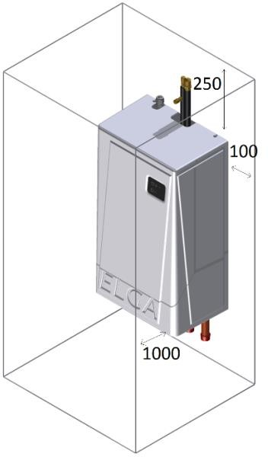Prevent noise or ventilation nuisance to the immediate vicinity.
  + Attach the outdoor unit with specialized materials for outdoor units (such as the mounting kits).
  + Avoid placement on or on structures that can easily transport the sound further, if necessary use specialized damping (such as wooden support structures).
  + Pay attention to the prescribed space around the outdoor unit.
  + The outdoor unit must be safe to reach for maintenance and/or replacement.
  + Pay attention to the distance between the indoor and outdoor unit.

Damage to the outdoor unit due to an industrial or maritime atmosphere is not covered by the warranty of the outdoor unit. The Progeen basic coating can protect the outdoor unit against this.

For the refrigerant pipes, a minimum distance of 2 meters and 15 meters applies without refilling. The maximum distance (with refilling) is 20 meters. For the refrigerant connection of the outdoor unit, the installer needs his F-gas papers.

The space occupied by the indoor unit is limited. The hydraulic connections are located at the bottom, the refrigerant connections at the top. Preferably place the indoor unit near the boiler or district heating.

The indoor unit is equipped with a grounded 230 Volt plug for the electrical power supply. The outdoor unit is powered from the indoor unit (4 * 1.5 mm² outer cable). The ELGA absorbs a maximum of 1.5 kW electrically. This should therefore also be available in the relevant electricity group.

# hydraulic connection central heating boiler general

The ELGA can be hydraulically connected in two ways. First, this can be done in parallel. This applies to most central heating boilers.

The second option is to connect the ELGA hydraulically with an open distributor in series. Apply this if the modulation range of the circulation pump in the boiler cannot be set, or only by the manufacturer, or if the tap water valve of the central heating boiler does not have a fixed resting position .

# hydraulic actuators central heating boiler connect in parallel

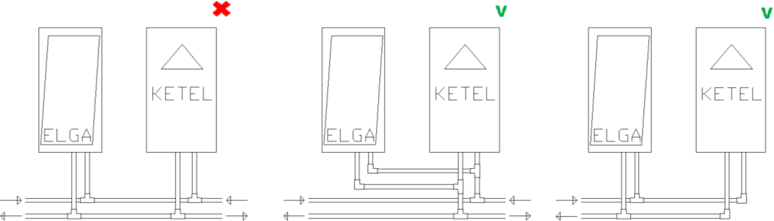In any case, keep in mind that the pipes of the ELGA and boiler / district heating first come together before they divide to the delivery system. See image below.

Place the supplied non-return valve at the central heating boiler on the same side as the three-way valve for tap water. The location is important to prevent a high pressure failure of the boiler.

The table below shows an overview of where the non-return valve should be placed if the ELGA is connected in parallel. If the Elga and central heating boiler/district heating are connected in series using an open distributor, then recoil clamps are not necessary.

|  |  |  |  |
| --- | --- | --- | --- |
| **Scheme** | **Position tap water valve central heating boiler** | **Resting position tap water valve** | **Position non-return valve central heating boiler\*** |
| F4.4 - 1 | Supply** | CV company | Supply |
|  | Supply** | Tap water company | Return or none |
|  | Supply** | Variable | Apply open distributor in series or holes in the check valve |
| F4.4 - 2 | Return | CV company | Return |
|  | Return | Tap water company | Supply or none |
|  | Return | Variable | Return |
| F4.4 - 3 | NA |  | Supply |

* If it is not known in which position the tap water valve is at rest, this should be checked with the supplier or manufacturer of the central heating boiler.

** In the drawing below, situation 1 can only be made if the tap water valve always goes back to the position for central heating company.

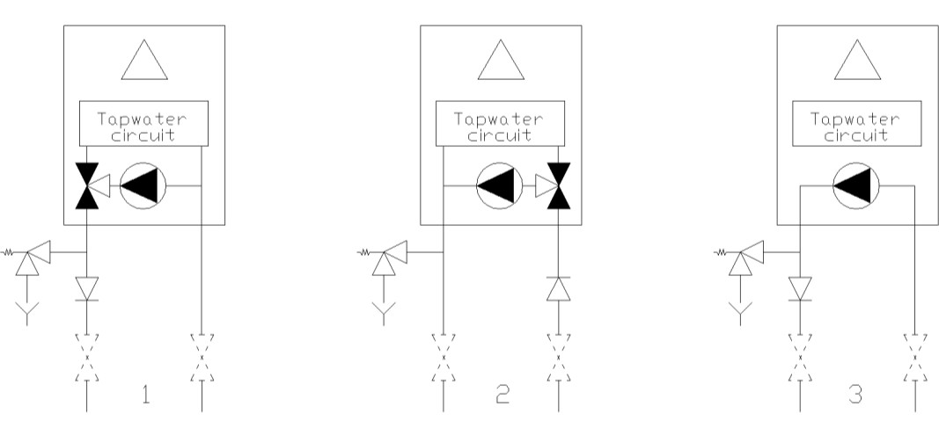

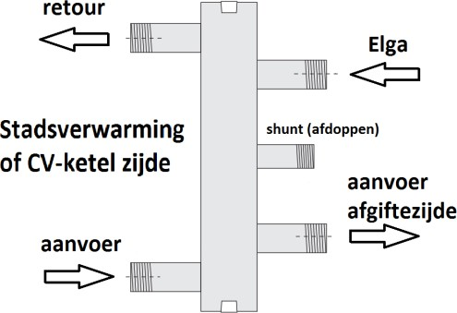**Hydraulic points of attention central heating boiler open distributor in series** When the ELGA and a central heating boiler are applied in series, a 1" open distributor must be applied that is connected according to the image shown below. A suitable open distributor is, for example, the Pentec open distributor 1" of 44 kW.

# hydraulic points of attention district heating open distributor in series

In the case of district heating, place a two-way valve in the supply of the district heating, so that it can be closed if there is no demand from the ELGA. The ELGA can use the on/off contact for the boiler to open the valve. This contact is suitable for up to 24 Volts (for the valve motor).

A 1" open distributor connected according to the image shown above should be applied. A suitable open distributor is, for example, the Pentec open distributor 1" of 44 kW.

If the delivery system has an open connection to the district heating network, there will be no need for an expansion tank and overflow. When valves are placed at the ELGA, the ELGA must have its own overflow. Note that it can also handle the pressure in the district heating network. If the delivery system is hydraulically separated from the district heating network (separation heat exchanger), then this is very likely already equipped with an expansion tank and overflow.

# delivery system and control

As with all heat pumps, for the ELGA, the lowest possible temperature of the delivery system is best for the highest possible efficiency. In an uninsulated home with a lot of 'ventilation' and single glazing and high release temperatures, an ELGA will probably not produce the desired result. Many boilers can be limited in their supply temperature. If there is doubt whether an ELGA can contribute sufficiently, limit the boiler to, for example, 50 °C supply temperature and see whether the house can be kept warm or even available at approximately 5 °C outside temperature.

The ELGA is also suitable for cooling. The delivery system must also be suitable for this. Underfloor heating and fan convectors (with condensation drain) are basically suitable for cooling. Please note that the corresponding (after)regulation is also suitable for cooling. In existing situations, this is often not the case.

If the entire house is equipped with underfloor heating, check whether it is possible to close the mixing function of the distributor. The ELGA can then supply a low temperature that no longer needs to be mixed. If necessary, the distributor can be replaced by a non-mixing model. Check whether the main pipes are of sufficient capacity to cope with a smaller temperature difference (higher volume flow).

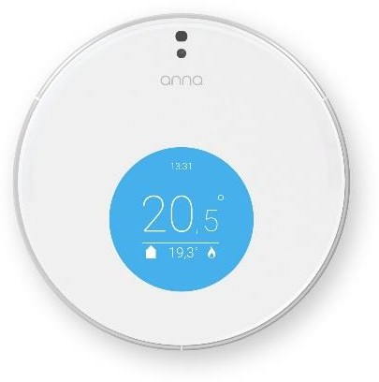With thermostatic control, place the room thermostat in a good reference room in the correct position (see thermostat manual). The standard thermostats are the Plugwise Anna smart thermostat and the Honeywell Chronotherm Touch Modulation (TH8210M1003). Several other thermostats can also be applied. When commissioning, it is useful to have a standard thermostat or laptop connected to the ELGA to activate the test mode, for example.

Some homes are equipped with zone/ post-regulation in the delivery system. Think, for example, of honeywell's EvoHome system or zone/post-regulation of the underfloor heating. In many cases, it is then desirable to release the zone/post-regulation of the ELGA if there is heat freezing. This can be done by setting the ELGA weather-dependent. An extra outside sensor on the north façade is then necessary (note, three-wire cables), as well as the extra cable (article number 60509) for the clearance of heating and / or cooling.

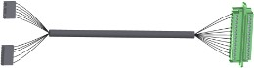ATTENTION! When using an EvoHome or similar adjustment system, the setting for the outside temperature limit must be maintained. Adjustments to this are at your own risk.

If it is possible that all groups are closed and/or there is insufficient free system hold left for the ELGA, then a spring-loaded by-pass must also be placed and possibly a buffer tank (in series in the return or parallel).

For all detailed options, see the installation manual.

# PRINCIPLE DIAGRAM ELGA & GAS BOILER

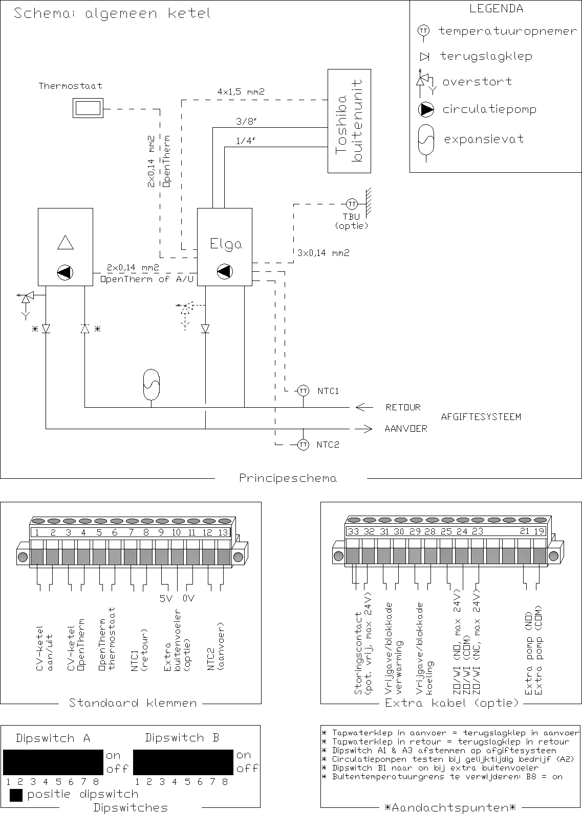

See the installation guide for detailed diagrams per option.

# PRINCIPLE DIAGRAM ELGA & DISTRICT HEATING WITH OPEN DISTRIBUTOR IN SERIES

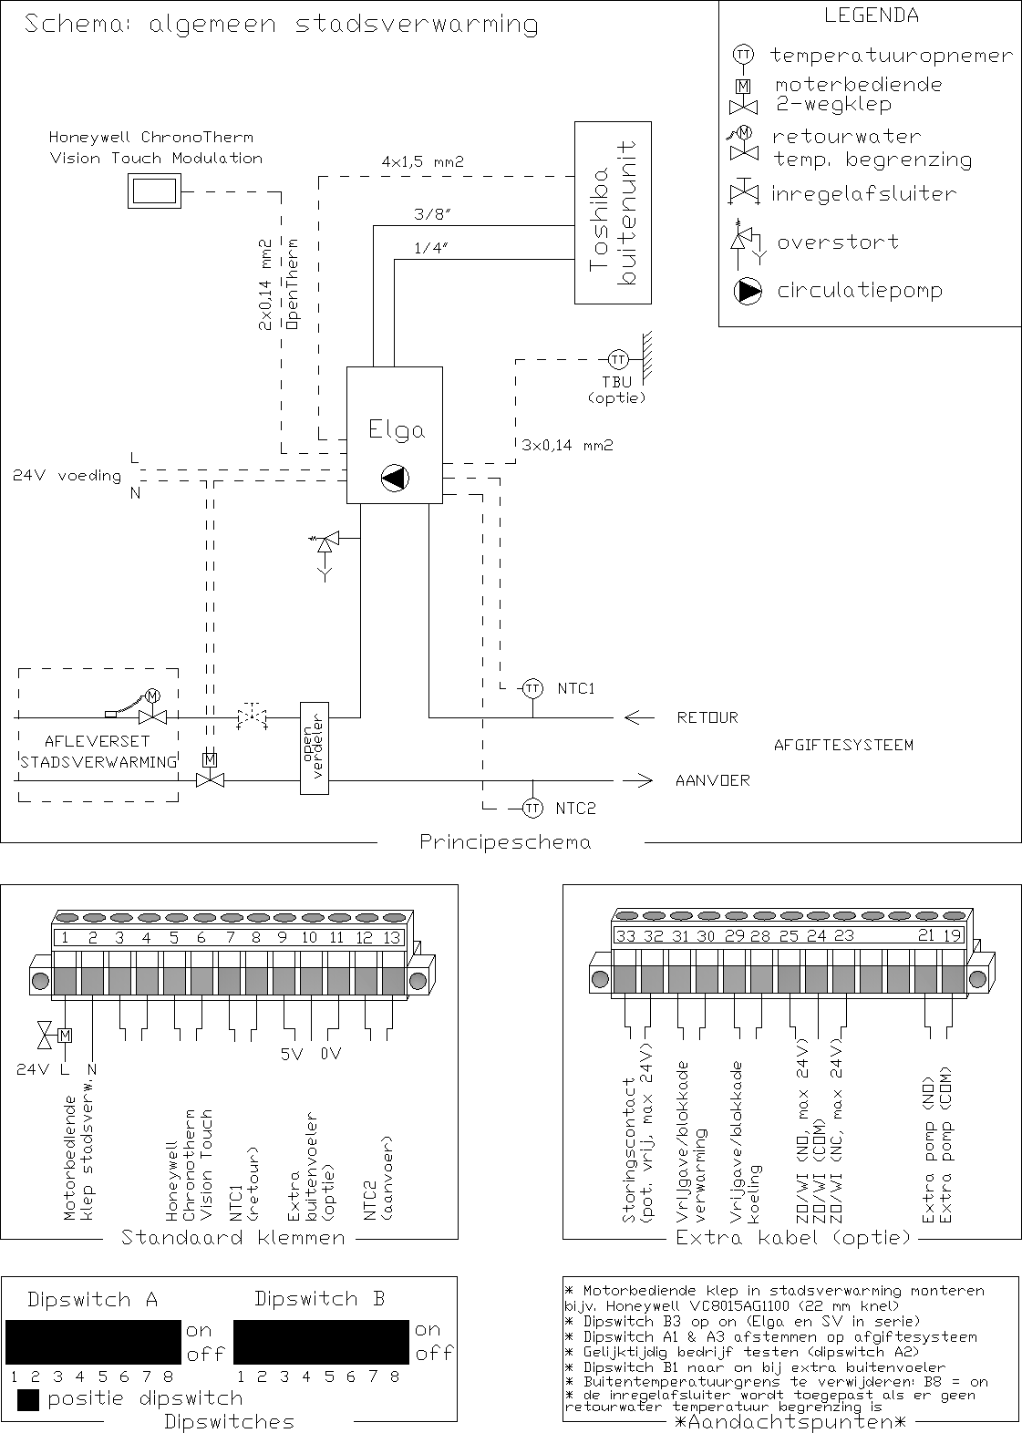

See the installation guide for detailed diagrams per option.

# TECHNICAL SPECIFICATIONS

|  |  |  |
| --- | --- | --- |
| **accomplishments** | **Techneco ELGA 304 used Tractor** |  |
| heating power (A12/W35) | 4,9 | Kw |
| heating power (A10/W35) | 4,6 | Kw |
| heating power (A7/W35)* | 4,2 | Kw |
| heating capacity (A2/W35)* | 3,2 | Kw |
| heating power (A7/W45)* | 3,8 | Kw |
| cooling capacity, variable | 2,5 | Kw |
| COP heating (A7/W35)* | 4,6 | - |
| COP heating (A7/W45)* | 3,4 | - |
| COP heating (A-7/W35)* | 2,7 | - |

* nominal values measured according to EN 14511 test frequency 50 Hz

**electric**

|  |  |  |
| --- | --- | --- |
| rated voltage | 1f / 50 HZ / 230 V | - |
| heating electrical power | 1.060 | W |
| heat compressor power intake | 5 | A |
| compressor start-up current | 5 | A |

**outdoor unit data**

|  |  |  |
| --- | --- | --- |
| manufactured | Toshiba |  |
| type | RAV-SM304 |  |
| sound pressure level at 5 meters (full load, free field setup) | 47 | dB(A) |
| sound power level (nominal) | 62 | dB(A) |
| dimensions (H x W x D) | 550 x 780 x 290 | Mm |
| net weight | 33 | Kg |
| air flow maximum | 1.800 | m³/h |
| type of connections | Flare |  |
| diameter pipe refrigerant liquid | 1/4 | inch |
| diameter pipe refrigerant gas | 3/8 | inch |
| minimum pipe length | 2 | m |
| maximum pipe length without refilling | 15 | m |
| maximum pipe length with refilling | 20 | m |
| refilling for pipes longer than 15m | 20 | g/m |
| maximum height difference | 10 | m |
| electric with indoor unit | 4 x 1.5 | mm² |
| refrigerant | R410A | - |
| refrigerant filling | 0,80 | Kg |

**indoor unit data**

|  |  |  |
| --- | --- | --- |
| manufactured | Techneco Hotels | - |
| dimensions hood (H x W x D) | 550 x 310 x 200 | Mm |
| dimensions incl. pipes (h x w x d) | 790 x 310 x 200 | Mm |
| net weight | 20 | Kg |
| thermostat connection | Opentherm | - |
| boiler connection | on/off or OpenTherm | - |
| hydraulic connections central heating system (2x) | 22 | Mm |
| minimum volume flow | 300 | l/h |

*All data and values are subject to change.*

# DRAWINGS INDOOR UNIT

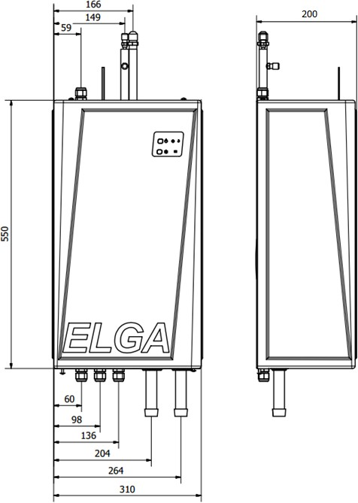

**DRAWINGS OUTDOOR UNIT**

